How to use bgchanger [v0.6.0b]

Preparation

1| Download ‘BC2’

2| Unzip it and it put it somewhere easy to access like your Desktop (not necessary)

Note: Don't edit anything other than ‘background.config’ (file content only, not the name) and copypasting backgrounds in any of the ‘background pool’ selection folders

Use

1| Execute ‘bgchanger.exe’

2| Press ENTER to change background

‘Background pool’ is the folder that contains all backgrounds bgchanger can use (all backgrounds must be in this folder, without any subfolders inside).
‘Background pool’ folder contains ‘backgrounds.config’ and a specific selection sub-folder with usable backgrounds will look similar to this:

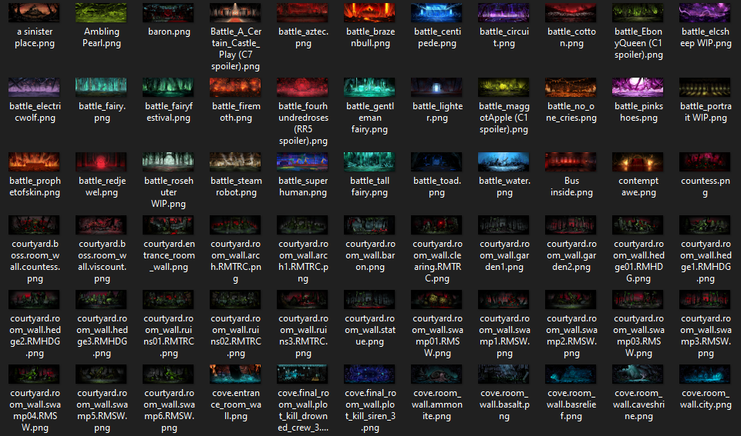

The very first time you try to change background, it will ask a few things:

- Game path: On the steam page of Darkest Dungeon, open local files and copy the whole path, then paste it inside bgchanger (dont mess this up or it gets messy to clean up).
The game path (‘.../Steam/steamapps/common/DarkestDungeon’) folder looks like this:
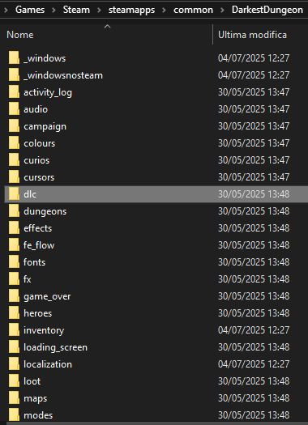

- Selection mode: simply write which selection mode you want to use , default is random (when changing from one mode to another, list of used backgrounds resets)

- Rank: simply write your current rank, if it changes in the future update it so bgchanger knows which background to replace
(game uses a certain background depending on your rank)
Subdivisions of your rank dont matter, just the name of the rank (whether you are novice 3, novice 2 or novice 1, you would just type novice if thats your current rank):

And you are done!
Any other time except the first time, bgchanger will ask once if you want to change your previous path,rank and selection mode, then it wont ever again until you close and open bgchanger again.
If you have issues with your paths, check and change them depending on the error you are getting.
If you have issues with your background, you might have forgotten to change your rank if it changed recently… If not, it's probably a bug you should tell me about!

NOTE: You HAVE to use bgchanger in the MAIN MENU of the game when changing backgrounds if you have audio banks and want them to work for custom music.

What does it do?

- (v0.1a) bgchanger chooses randomly among all backgrounds from input folder (selected background is also excluded and won't be picked again until next cycle begins) and replaces currently used background in circus with the one that gets selected

- (v0.2a) while selecting a background, it also searches for a configuration of the selected background inside ‘backgrounds.config.txt’ (which needs to be inside the input folder).
If it finds a configuration for the selected background, it will also apply those along with applying background, if instead configuration is not specified it will use default config (which corresponds to colour grade ‘default’ and effect ‘none’)

- (0.3a) while selecting a background, it also searches for a configuration of the selected background inside ‘backgrounds.config.txt’ like (0.2a) but now it also applies music to use along the background, which will be default circus music if not specified

- (0.4b) previous selection mode designed as ‘random’, new selection mode added ‘progressive’.
If ‘progressive’ selection mode is chosen it will cycle backgrounds like this (spoilers ahead):
[0] crypts > [7] weald > [16] warrens > [25] cove > [35] courtyard > [55] farmstead > [64] town > [68] darkest dungeon >>>
[86] catacombs > [95] caverns > [104] treasury > [113] exposed interior > [N/A] unsupported

- (0.4.1b) added custom loading screens used depending on which area / boss background comes from, and bgchanger already starts with progression backgrounds ready to use
- (0.5.0b) added custom torches used depending on which area the background comes from and a way to change round_indicator position depending on the torch being custom or not.

- (0.5.0b) bgchanger now chooses which folder to choose backgrounds from depending on the selection mode and will not read outside of the dedicated folder.

- (0.5.0b) simplified requirements by asking only the general game path instead of 4 specific paths (which would have became 6 at this point were it not for this)

- (0.5.1b) added ‘restore_circus’ command to restore original files that are normally modified by bgchanger

- (0.5.1b) added debug mode to make debug logs only visible when active

- (0.6.0b) added ‘direct’ selection mode, which allows to choose any background by name among the ones inside the dedicated ‘direct’ background folder, bypassing cycle restriction

- (0.6.0b) remade ‘comet’ torch, added 4 spacetime backgrounds and 4 new ‘comet’ torch variations (one for each spacetime bg), also added 4 new music loops (1 for each spacetime bg)

- (0.6.0b) added ‘effects’ folder, added new keywords for ‘effect’ field (keyword ‘none’ replaced by ‘default) which changes multiple files depending on its value (corpses, halos and coinflip animations are currently the focus)

